**DAILY ONLINE ACTIVITIES SUMMARY**

|  |  |  |  |  |  |  |  |  |
| --- | --- | --- | --- | --- | --- | --- | --- | --- |
| **Date:** | **4/06/2020** | | | | | **Name:** | **SPOORTI DAROJI** | |
| **Sem & Sec** | **4th SEM. & ‘B’ SEC.** | | | | | **USN:** | **4AL18CS088** | |
| **Online Test Summary** | | | | | | | | |
| **Subject** | | **MICROCONTROLLER AND EMBEDDED SYSTEM** | | | | | | |
| **Max. Marks** | | **20** | | **Score** | | | **14** | |
| **Certification Course Summary** | | | | | | | | |
| **Course** | **Intro to Django for Web development** | | | | | | | |
| **Certificate Provider** | | | **Udemy** | | **Duration** | | | **3Hrs.** |
| **Coding Challenges** | | | | | | | | |
| **Problem Statement 1: Write a C++ program to find the missing number in array**  **Problem Statement2: write a java program to read three integer values from the keyboard and find the sum of the values. Declare a variable "sum" of type int and store the result in it.** | | | | | | | | |
| **Status: Executed** | | | | | | | | |
| **Uploaded the report in Github** | | | | | **Yes** | | | |
| **If yes Repository name** | | | | | [alvas-education-foundation](https://github.com/alvas-education-foundation)/[spoorti_daroji](https://github.com/alvas-education-foundation/spoorti_daroji) [spoorti_daroji](https://github.com/alvas-education-foundation/spoorti_daroji)/coding_solutions/ | | | |
| **Uploaded the report in slack** | | | | | **Yes** | | | |

**Online Test Summary: 18CS44 test was scheduled from 2:00 PM to 2:30PM .The portion for the IA was the 3rd module. There were 20 questions and the time assigned was 30 minutes. The questions were MCQ types.**

**Online Certification course Summary: In today's session I learnt how to create the project and how to create an appsight project and navigate project and about the files and what they do**

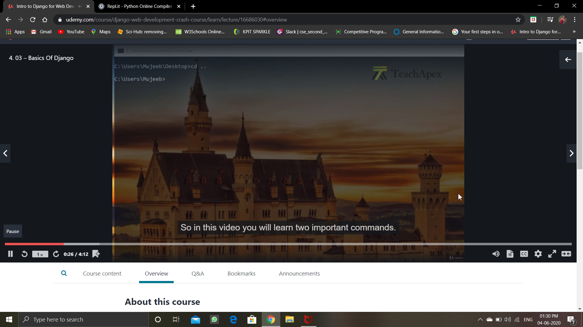

**Online Coding Summary:**

**Today I received one program from prof. Shilpa CSE Dept, the other from Prof. Reena Lobo CSE Dept. The program is mentioned above in the coding challenges(pg.01). I have also uploaded it to my Github repository.**

**The program is mentioned above in the coding challenges.I have written a program and uploaded it to my Github repository, as shown in the below.**

